2016 Don Bartholomew Award for Excellence in Public Relations Research
Sponsored by Ketchum Global Research & Analytics
A Grant & Internship Program
Research Prospectus
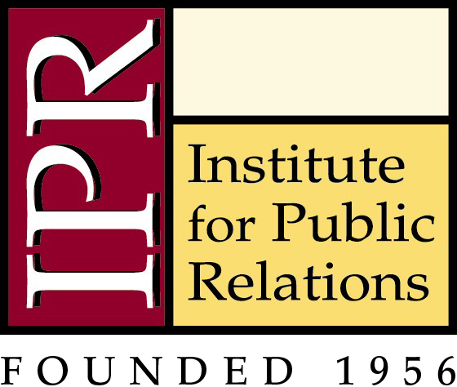

Name:
Permanent Address:
City: State: Zip:
Telephone:
E-mail Address:

Statement must be no more than five pages in length. Statement can be in electronic format.

The Research Question:
Your research paper is intended for immediate use by practitioners. The Institute for Public Relations has five recommended topics below. Additional topics may also be considered.

Please include 2-3 sentences describing why this research is important, how it matters to the practice of public relations and how it applies to practitioners.

IPR Priority Topics:
- What drives choice and changes behavior? What can we draw from behavioral sciences, sociology, psychology and neuropsychology to apply to public relations practice? What are the emotional and rational drivers of belief, commitment and behavior? How do different stakeholders – and different generations – process differently in this regard?
- Organizational communication. Our Commission on Organizational Communication is developing an agenda as knowledge aggregator, model innovator and thought leader in the area of employee engagement.
- A broader context for social networking and what it means. While others churn out benchmarking, best practices and metrics around social media – and IPR has a role in aggregating that knowledge – our main interest is digging deeper into the true mechanisms of relationship-building, trust, influence and the socialization of ideas across the fragmented world of social networking.
- Restoring reputation in an environment of extremely low trust. Beyond the benchmark trust studies that track ups and downs, what can we learn from the deeper social science of trust? What reliable data exist to identify the levers that most influence reputation today? What is the future of organizational trust in a younger, G-20 world?
- Models to predict the probability of public relationship outcomes. Across countries and cultures, audiences and generations, what are the research-proven models to reliably predict whether and when public relations can affect outcomes?

The Research Methodology:

Discuss briefly the various methodologies that you plan to use in carrying out your research project. Explain why you have chosen those particular methodologies. The research may be theoretical, use secondary research, or be a primary research project (qualitative or quantitative). If this project uses primary research methods, please describe.

Result:

What will be the result of this research? How will the findings be communicated and to whom is it relevant?

