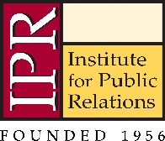
IPR ANNUAL DISTINGUISHED LECTURE AWARDS NOMINATION FORM
Please fill out the application below and provide the requested information about the nominee. Please note that only complete applications will be accepted.
Name of Award:
Name of Nominee:
Affiliation of Nominee:
Your name:
Your affiliation:
Your email:
Your phone:

Are any others joining you in this nomination? If so, list their names and affiliations here:

Below, please provide information and answer the following questions about the nominee.
- Please provide a biography of the nominee (max 150 words):
- How do you know the nominee (max 100 words)?
- How does the nominee meet the criteria for this award? (max 500 words)?

Please click the link below for criteria for each of the awards.
Alexander Hamilton Medal
Pathfinder Award
Jack Felton Medal for Lifetime Achievement

Nominations should be submitted to info@instituteforpr.org. Please indicate the award in the subject line. Deadline for applications is May 15, 2019.

